As per normal values used in the paper

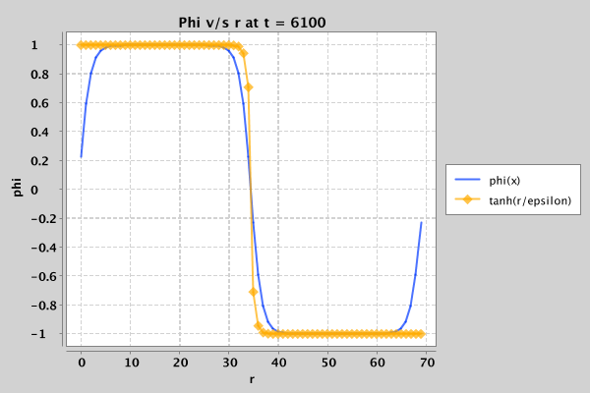

tanh(r/2.5ε) curve with a and k unchanged

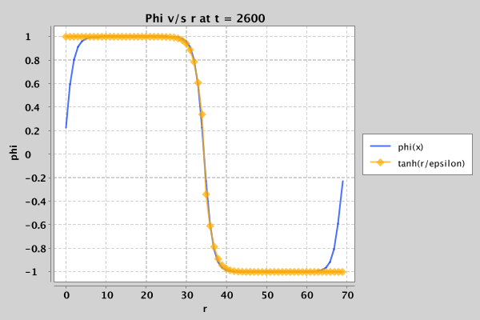

k’ = 2.5 k

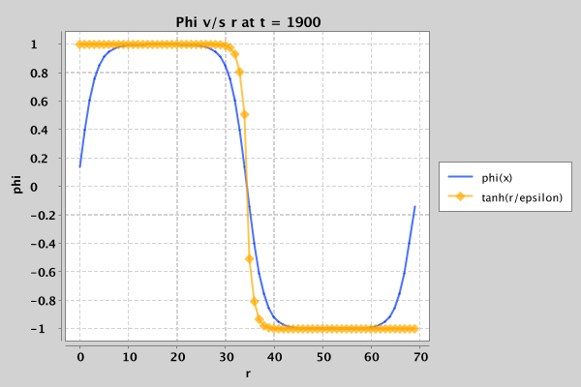

(Can’t take k’=2.5\*2.5 since phi goes to infinity)

a' = a / (2.5 \* 2.5)

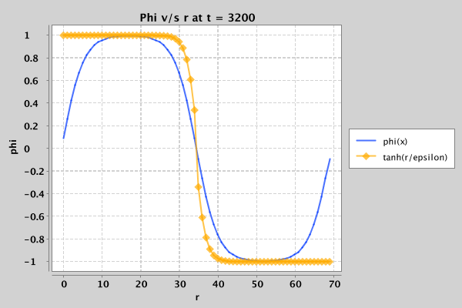

Error

